**Ideation Phase**

**Empathize & Discover**

|  |  |
| --- | --- |
| Project Name | Snack Squad: A Customizable Snack Ordering and Delivery App |
| Maximum Marks | 4 Marks |

**Empathy Map Canvas:**

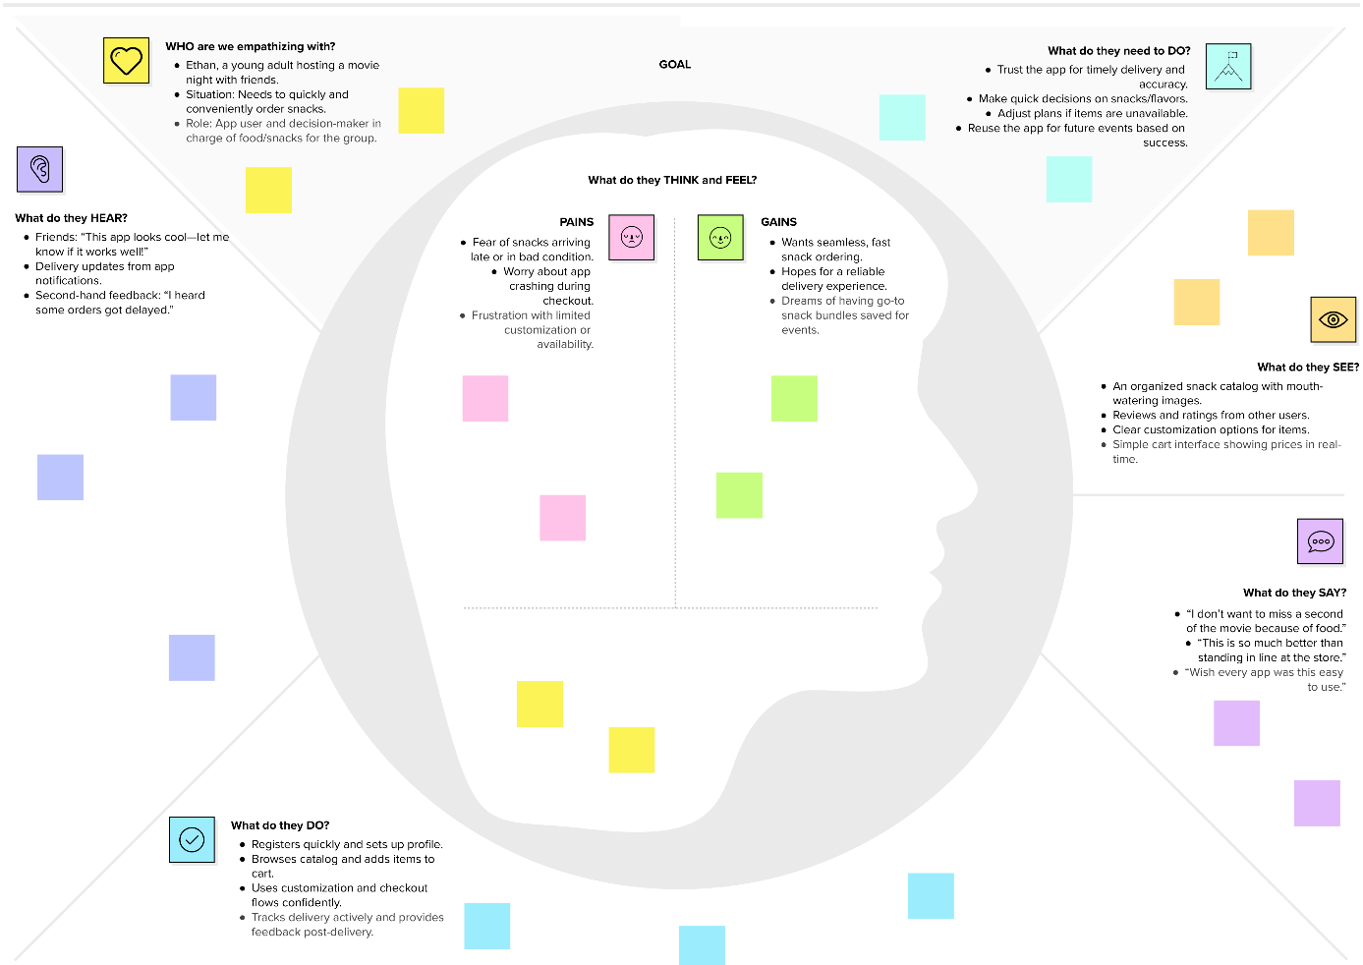

Reference: <https://www.mural.co/templates/empathy-map-canvas>